H.T No
Regulations:
A15


Sreenidhi Institute of Science and Technology
(An Autonomous Institution)
Code No: 5B730 Date:11-May-2019 (AN)

B.Tech IV-Year I-Semester External Examination, May-2019 (Supplementary)
Finite Element Method (ME)

Time: 3 Hours Max.Marks:75

Note: a) No additional answer sheets will be provided.
b) All sub-parts of a question must be answered at one place only, otherwise it will not be valued.
c) Missing data can be assumed suitably.

Part - A Max.Marks:25

Answer all QUESTIONS.

1. | Define principle of minimum potential energy. | [3M]
2. | Discuss the load vector for uniformly varying load on beam element. | [3M]
3. | Write the load vector for a CST element which is subjected to uniform pressure on an edge at an angle. | [3M]
4. | Write the shape functions for a two dimensional four node quadrilateral element by using Lagrange interpolation. | [3M]
5. | Write the principle involved in Galerkin approach? | [3M]
6. | Differentiate lumped and consistent mass matrices for a bar element. | [2M]
7. | How do you consider the temperature effect in Truss element? | [2M]
8. | What is the necessity of numerical integration and name some methods. | [2M]
9. | What is meant by pre processing? | [2M]
10. | Write the conditions required for a solid to model it as axi-symmetric solid problem | [2M]
Part – B Max.Marks:50
ANSWER ANY FIVE QUESTIONS. EACH QUESTION CARRIES 10 MARKS.

11. |  | An axial load P = 200x 10³N is applied on a bar as shown in Fig.1. Determine
 | a) | the nodal displacements and | [5M]
 | b) | the stress in each material and the reaction forces.  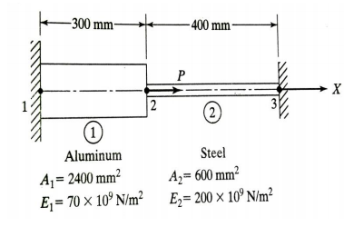  Fig-1 | [5M]
12. |  | A three bar truss is shown in Fig.2. The modulus of elasticity of the material is 300 x 10³ N/mm² . The area of the bar used for the truss is 60 mm² for all the elements. The length L₁ = 750 mm and L₂ = 100 mm. The load P₁ = 20 kN and P₂ = 25 kN. Determine
 | a) | The element stiffness matrix for each element and | [5M]
 | b) | The global stiffness matrix.  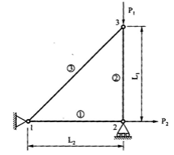  Fig-2 | [5M]
13. | a) | Derive the shape functions for a CST element | [5M]
 | b) | For the axi-symmetric element shown in Fig.3, develop the stiffness matrix. E-200 GPa, ν=0.3. units are in mm.  z  3(0,40)  1(0,0) 2(50,0) r  Fig-3 | [5M]
14. |  | For the iso-parametric quadrilateral element shown in Fig.4, with the Cartesian co-ordinates.in mm. Evaluate
 | a) | Shape functions and | [5M]
 | b) | Jacobian matrix.  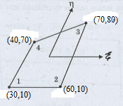  Fig-4 | [5M]
15. |  | Derive the heat conduction matrix for two dimensional steady state heat transfer problem . | [10M]
16. |  | Determine the natural circular frequencies of vibration of a Simply supported beam of length L shown in Fig.5, by using two elements, assuming constant values of ρ, E, and A.  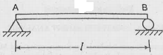  Fig-5 | [10M]
17. | a) | List and describe the general steps of finite element method. | [5M]
 | b) | Determine the displacement and rotation under the force and moment located at the center of the beam shown in Figure 6. The beam has been discretized into the two elements shown in Fig. 6. The beam is fixed at each end. A downward force of 10 kN and an applied moment of 20 kN-m act at the center of the beam. Let E = 210 GPa and I = 4 x 10⁻⁴ m⁴ throughout the beam length.  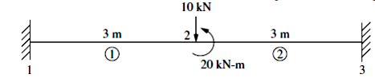  Fig-6 | [5M]
18. | a) | Evaluate the integral by two point Gaussian quadrature,  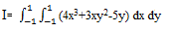 | [5M]
 | b) | Explain finite element formulation of 3 dimensional structural problems. | [5M]

-- 00 -- 00 –

